Judging changes.

Survey Flow

EmbeddedData

test = 1

BlockRandomizer: 1 - Evenly Present Elements

Branch: New Branch

If

If test Is Equal to 1

Block: Qualification test (increasing) (5 Questions)

Branch: New Branch

If

If How much did the value change from 2015 to 2017? 50 Is Selected

BlockRandomizer: 1 - Evenly Present Elements

Branch: New Branch

If

If test Is Equal to 1

Block: Happiness in Oswa (1 Question)

Branch: New Branch

If

If Carefully read the following instructions. The next screen will display a graph of annual happine... Is Displayed

BlockRandomizer: 1 - Evenly Present Elements

Branch: New Branch

If

If test Is Equal to 1

Block: 18 inc_hap_Oswa_wgrid (2 Questions)

EmbeddedData

direction = increasing

valence = happiness

gridline = yes

city = Oswa

Branch: New Branch

If

If test Is Equal to 1

Block: 15 inc_hap_Oswa_nogrid (2 Questions)

EmbeddedData

direction = increasing

valence = happiness

gridline = no

city = Oswa

Block: happiness response (1 Question)

Branch: New Branch

If

If test Is Equal to 1

Block: Sadness in Oswa (1 Question)

Branch: New Branch

If

If Carefully read the following instructions. The next screen will display a graph of annual sadness... Is Displayed

BlockRandomizer: 1 - Evenly Present Elements

Branch: New Branch

If

If test Is Equal to 1

Block: 21 inc_sad_Oswa_nogrid (2 Questions)

EmbeddedData

direction = increasing

valence = sadness

gridline = no

city = Oswa

Branch: New Branch

If

If test Is Equal to 1

Block: 24 inc_sad_Oswa_wgrid (2 Questions)

EmbeddedData

direction = increasing

valence = sadness

gridline = yes

city = Oswa

Block: sadness response (1 Question)

Branch: New Branch

If

If test Is Equal to 1

Block: Happiness in Escor (1 Question)

Branch: New Branch

If

If Carefully read the following instructions. The next screen will display a graph of annual happine... Is Displayed

BlockRandomizer: 1 - Evenly Present Elements

Branch: New Branch

If

If test Is Equal to 1

Block: 14 inc_hap_Escor_nogrid (2 Questions)

EmbeddedData

direction = increasing

valence = happiness

gridline = no

city = Escor

Branch: New Branch

If

If test Is Equal to 1

Block: 17 inc_hap_Escor_wgrid (2 Questions)

EmbeddedData

direction = increasing

valence = happiness

gridline = yes

city = Escor

Block: happiness response (1 Question)

Branch: New Branch

If

If test Is Equal to 1

Block: Sadness in Escor (1 Question)

Branch: New Branch

If

If Carefully read the following instructions. The next screen will display a graph of annual sadness... Is Displayed

BlockRandomizer: 1 - Evenly Present Elements

Branch: New Branch

If

If test Is Equal to 1

Block: 20 inc_sad_Escor_nogrid (2 Questions)

EmbeddedData

direction = increasing

valence = sadness

gridline = no

city = Escor

Branch: New Branch

If

If test Is Equal to 1

Block: 23 inc_sad_Escor_wgrid (2 Questions)

EmbeddedData

direction = increasing

valence = sadness

gridline = yes

city = Escor

Block: sadness response (1 Question)

Branch: New Branch

If

If test Is Equal to 1

Block: Happiness in Aflos (1 Question)

Branch: New Branch

If

If Carefully read the following instructions. The next screen will display a graph of annual happine... Is Displayed

BlockRandomizer: 1 - Evenly Present Elements

Branch: New Branch

If

If test Is Equal to 1

Block: 13 inc_hap_Alfos_nogrid (2 Questions)

EmbeddedData

direction = increasing

valence = happiness

gridline = no

city = Alfos

Branch: New Branch

If

If test Is Equal to 1

Block: 16 inc_hap_Alfos_wgrid (2 Questions)

EmbeddedData

direction = increasing

valence = happiness

gridline = yes

city = Alfos

Block: happiness response (1 Question)

Branch: New Branch

If

If test Is Equal to 1

Block: Sadness in Alfos (1 Question)

Branch: New Branch

If

If Carefully read the following instructions. The next screen will display a graph of annual sadness... Is Displayed

BlockRandomizer: 1 - Evenly Present Elements

Branch: New Branch

If

If test Is Equal to 1

Block: 19 inc_sad_Alfos_nogrid (2 Questions)

EmbeddedData

direction = increasing

valence = sadness

gridline = no

city = Alfos

Branch: New Branch

If

If test Is Equal to 1

Block: 22 inc_sad_Alfos_wgrid (2 Questions)

EmbeddedData

direction = increasing

valence = sadness

gridline = yes

city = Aflos

Block: sadness response (1 Question)

Branch: New Branch

If

If How much did the value change from 2015 to 2017? 50 Is Not Selected

EndSurvey: Advanced

Branch: New Branch

If

If test Is Equal to 1

Standard: Qualification test (decreasing) (5 Questions)

Branch: New Branch

If

If How much did the value change from 2015 to 2017? -50 Is Selected

BlockRandomizer: 1 - Evenly Present Elements

Branch: New Branch

If

If test Is Equal to 1

Block: Happiness in Oswa (1 Question)

Branch: New Branch

If

If Carefully read the following instructions. The next screen will display a graph of annual happine... Is Displayed

BlockRandomizer: 1 - Evenly Present Elements

Branch: New Branch

If

If test Is Equal to 1

Block: 3 dec_hap_Oswa_nogrid (2 Questions)

EmbeddedData

direction = decreasing

valence = happiness

gridline = no

city = Oswa

Branch: New Branch

If

If test Is Equal to 1

Block: 6 dec_hap_Oswa_wgrid (2 Questions)

EmbeddedData

direction = decreasing

valence = happiness

gridline = yes

city = Oswa

Block: happiness response (1 Question)

Branch: New Branch

If

If test Is Equal to 1

Block: Sadness in Oswa (1 Question)

Branch: New Branch

If

If Carefully read the following instructions. The next screen will display a graph of annual sadness... Is Displayed

BlockRandomizer: 1 - Evenly Present Elements

Branch: New Branch

If

If test Is Equal to 1

Block: 9 dec_sad_Oswa_nogrid (2 Questions)

EmbeddedData

direction = decreasing

valence = sadness

gridline = no

city = Oswa

Branch: New Branch

If

If test Is Equal to 1

Block: 12 dec_sad_Oswa_wgrid (2 Questions)

EmbeddedData

direction = decreasing

valence = sadness

gridline = yes

city = Oswa

Block: sadness response (1 Question)

Branch: New Branch

If

If test Is Equal to 1

Block: Happiness in Escor (1 Question)

Branch: New Branch

If

If Carefully read the following instructions. The next screen will display a graph of annual happine... Is Displayed

BlockRandomizer: 1 - Evenly Present Elements

Branch: New Branch

If

If test Is Equal to 1

Block: 2 dec_hap_Escor_nogrid (2 Questions)

EmbeddedData

direction = decreasing

valence = happiness

gridline = no

city = Escor

Branch: New Branch

If

If test Is Equal to 1

Block: 5 dec_hap_Escor_wgrid (2 Questions)

EmbeddedData

direction = decreasing

valence = happiness

gridline = yes

city = Escor

Block: happiness response (1 Question)

Branch: New Branch

If

If test Is Equal to 1

Block: Sadness in Escor (1 Question)

Branch: New Branch

If

If Carefully read the following instructions. The next screen will display a graph of annual sadness... Is Displayed

BlockRandomizer: 1 - Evenly Present Elements

Branch: New Branch

If

If test Is Equal to 1

Block: 8 dec_sad_Escor_nogrid (2 Questions)

EmbeddedData

direction = decreasing

valence = sadness

gridline = no

city = Escor

Branch: New Branch

If

If test Is Equal to 1

Block: 11 dec_sad_Escor_wgrid (2 Questions)

EmbeddedData

direction = decreasing

valence = sadness

gridline = yes

city = Escor

Block: sadness response (1 Question)

Branch: New Branch

If

If test Is Equal to 1

Block: Happiness in Aflos (1 Question)

Branch: New Branch

If

If Carefully read the following instructions. The next screen will display a graph of annual happine... Is Displayed

BlockRandomizer: 1 - Evenly Present Elements

Branch: New Branch

If

If test Is Equal to 1

Block: 1 dec_hap_Alfos_nogrid (2 Questions)

EmbeddedData

direction = decreasing

valence = happiness

gridline = no

city = Aflos

Branch: New Branch

If

If test Is Equal to 1

Block: 4 dec_hap_Alfos_wgrid (2 Questions)

EmbeddedData

direction = decreasing

valence = happiness

gridline = yes

city = Aflos

Block: happiness response (1 Question)

Branch: New Branch

If

If test Is Equal to 1

Block: Sadness in Alfos (1 Question)

Branch: New Branch

If

If Carefully read the following instructions. The next screen will display a graph of annual sadness... Is Displayed

BlockRandomizer: 1 - Evenly Present Elements

Branch: New Branch

If

If test Is Equal to 1

Block: 7 dec_sad_Alfos_nogrid (2 Questions)

EmbeddedData

direction = decreasing

valence = sadness

gridline = no

city = Aflos

Branch: New Branch

If

If test Is Equal to 1

Block: 10 dec_sad_Alfos_wgrid (2 Questions)

EmbeddedData

direction = decreasing

valence = sadness

gridline = yes

city = Aflos

Block: sadness response (1 Question)

Branch: New Branch

If

If How much did the value change from 2015 to 2017? -50 Is Not Selected

EndSurvey: Advanced

WebService: GET - http://reporting.qualtrics.com/projects/randomNumGen.php - Fire and Forget

|  |  |
| --- | --- |
| Page Break |  |

Start of Block: Qualification test (increasing)



Q11 Use the graph below to answer the questions that follow.



Qualification test (

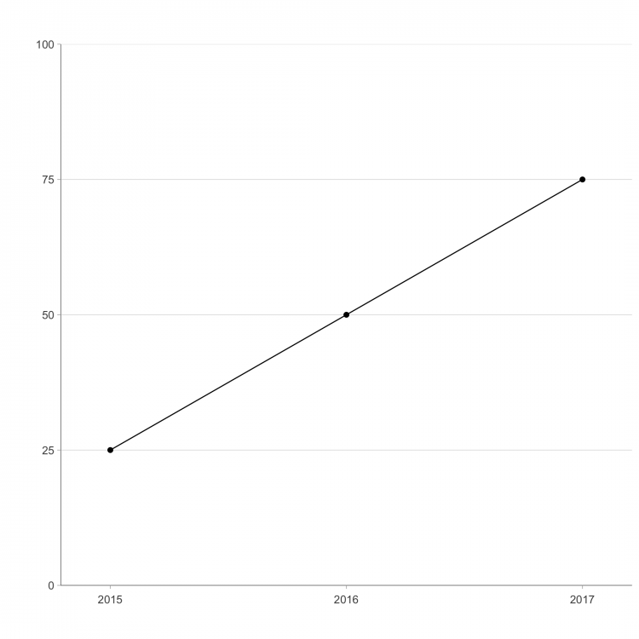



Q5 For the three years shown on the graph, which is the minimum value?

* 0 (1)
* 25 (2)
* 50 (3)
* 75 (4)
* 100 (5)



Q8 For the three years shown on the graph, which is the maximum value?

* 0 (1)
* 25 (2)
* 50 (3)
* 75 (4)
* 100 (5)



Q10 How much did the value change from 2015 to 2017?

* 0 (1)
* 25 (2)
* 50 (3)
* 75 (4)
* 100 (5)

End of Block: Qualification test (increasing)

Start of Block: Happiness in Oswa



Q17   
Carefully read the following instructions.  
  
The next screen will display a graph of annual happiness scores for the city of Oswa over the last three years. The graph will be shown for 20 seconds. Study it carefully during this time. You will then be asked a question about this graph. Please answer the question as quickly but accurately as possible.  
  
  
When you are ready, proceed to view the graph.

End of Block: Happiness in Oswa

Start of Block: 18 inc_hap_Oswa_wgrid



Q29 Timing

First Click (1)

Last Click (2)

Page Submit (3)

Click Count (4)



inc_hap_Oswa_wgrid

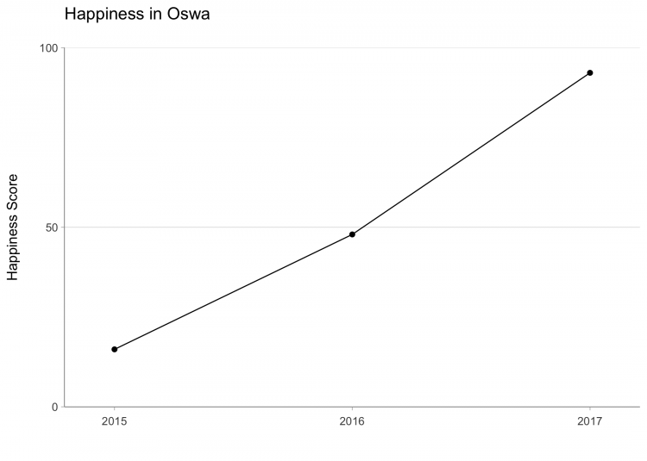

End of Block: 18 inc_hap_Oswa_wgrid

Start of Block: 15 inc_hap_Oswa_nogrid



Q27 Timing

First Click (1)

Last Click (2)

Page Submit (3)

Click Count (4)



inc_hap_Oswa_nogrid

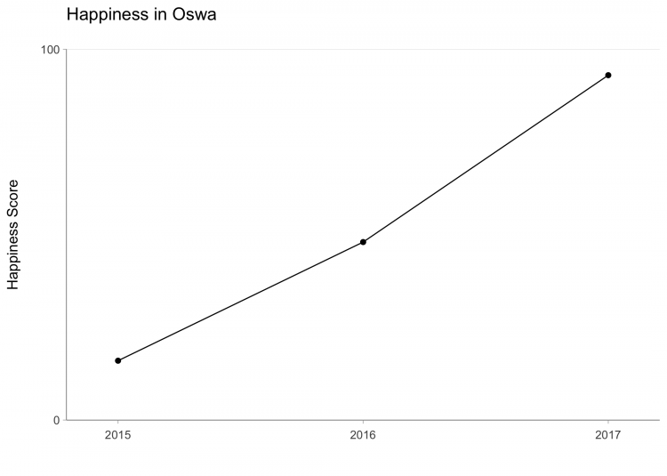

End of Block: 15 inc_hap_Oswa_nogrid

Start of Block: happiness response



happiness response Indicate how much the Happiness Score changed between 2015 and 2017.

|  |  |  |  |  |  |  |  |  |  |  |  |  |  |  |  |  |  |
| --- | --- | --- | --- | --- | --- | --- | --- | --- | --- | --- | --- | --- | --- | --- | --- | --- | --- |
|  | -100 | -88 | -75 | -63 | -50 | -38 | -25 | -13 | 0 | 13 | 25 | 38 | 50 | 63 | 75 | 88 | 100 |

|  |  |
| --- | --- |
| Happiness Score Change (1) |  |

End of Block: happiness response

Start of Block: Sadness in Oswa



Q20   
Carefully read the following instructions.  
  
The next screen will display a graph of annual sadness scores for the city of Oswa over the last three years. The graph will be shown for 20 seconds. Study it carefully during this time. You will then be asked a question about this graph. Please answer the question as quickly but accurately as possible.  
  
  
When you are ready, proceed to view the graph.

End of Block: Sadness in Oswa

Start of Block: 21 inc_sad_Oswa_nogrid



Q37 Timing

First Click (1)

Last Click (2)

Page Submit (3)

Click Count (4)



inc_sad_Oswa_nogrid

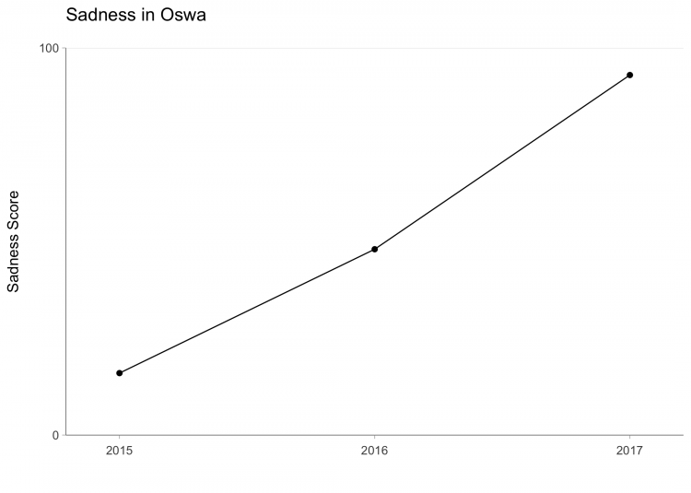

End of Block: 21 inc_sad_Oswa_nogrid

Start of Block: 24 inc_sad_Oswa_wgrid



Q39 Timing

First Click (1)

Last Click (2)

Page Submit (3)

Click Count (4)



inc_sad_Oswa_wgrid

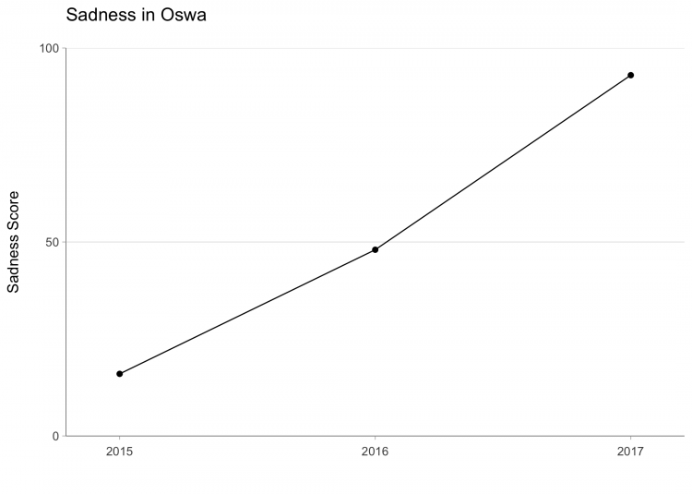

End of Block: 24 inc_sad_Oswa_wgrid

Start of Block: sadness response



sadness response Indicate how much the Sadness Score changed between 2015 and 2017.

|  |  |  |  |  |  |  |  |  |  |  |  |  |  |  |  |  |  |
| --- | --- | --- | --- | --- | --- | --- | --- | --- | --- | --- | --- | --- | --- | --- | --- | --- | --- |
|  | -100 | -88 | -75 | -63 | -50 | -38 | -25 | -13 | 0 | 13 | 25 | 38 | 50 | 63 | 75 | 88 | 100 |

|  |  |
| --- | --- |
| Happiness Score Change (1) |  |

End of Block: sadness response

Start of Block: Happiness in Escor



Q18   
Carefully read the following instructions.  
  
The next screen will display a graph of annual happiness scores for the city of Escor over the last three years. The graph will be shown for 20 seconds. Study it carefully during this time. You will then be asked a question about this graph. Please answer the question as quickly but accurately as possible.  
  
  
When you are ready, proceed to view the graph.

End of Block: Happiness in Escor

Start of Block: 14 inc_hap_Escor_nogrid



Q61 Timing

First Click (1)

Last Click (2)

Page Submit (3)

Click Count (4)



inc_hap_Escor_nogrid

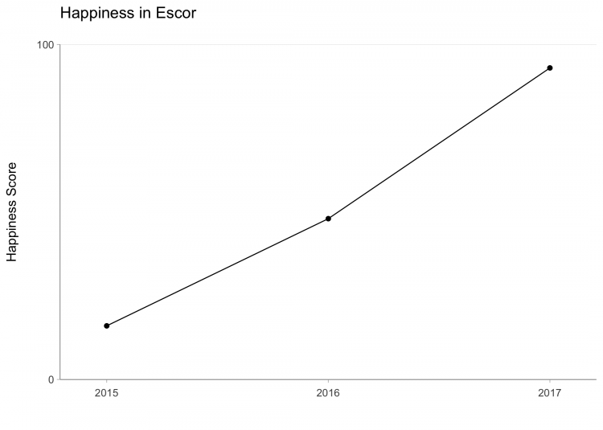

End of Block: 14 inc_hap_Escor_nogrid

Start of Block: 17 inc_hap_Escor_wgrid



Q63 Timing

First Click (1)

Last Click (2)

Page Submit (3)

Click Count (4)



inc_hap_Escor_wgrid

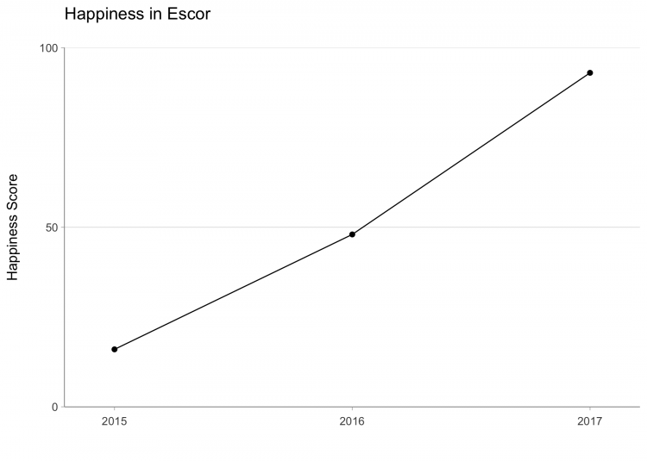

End of Block: 17 inc_hap_Escor_wgrid

Start of Block: Sadness in Escor



Q21   
Carefully read the following instructions.  
  
The next screen will display a graph of annual sadness scores for the city of Escor over the last three years. The graph will be shown for 20 seconds. Study it carefully during this time. You will then be asked a question about this graph. Please answer the question as quickly but accurately as possible.  
  
  
When you are ready, proceed to view the graph.

End of Block: Sadness in Escor

Start of Block: 20 inc_sad_Escor_nogrid



Q69 Timing

First Click (1)

Last Click (2)

Page Submit (3)

Click Count (4)



inc_sad_Escor_nogrid

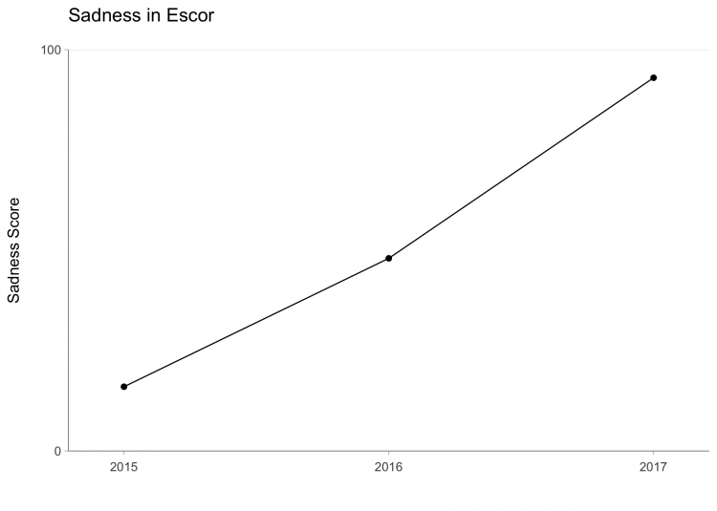

End of Block: 20 inc_sad_Escor_nogrid

Start of Block: 23 inc_sad_Escor_wgrid



Q71 Timing

First Click (1)

Last Click (2)

Page Submit (3)

Click Count (4)



inc_sad_Escor_wgrid

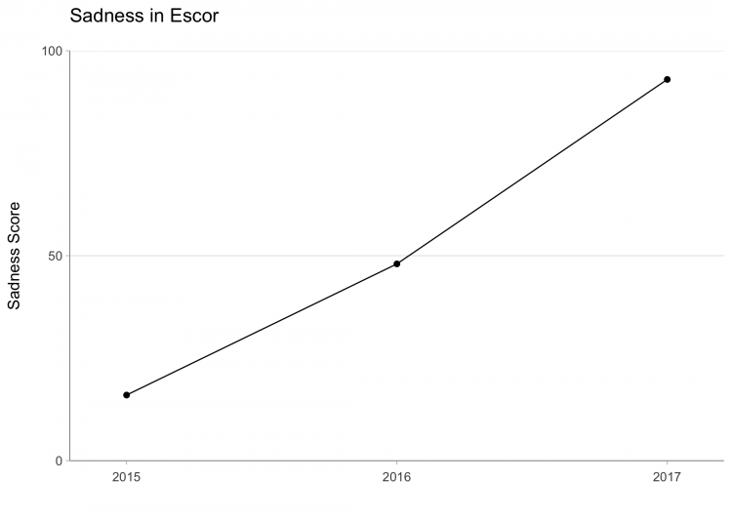

End of Block: 23 inc_sad_Escor_wgrid

Start of Block: Happiness in Aflos



Q19   
Carefully read the following instructions.  
  
The next screen will display a graph of annual happiness scores for the city of Alfos over the last three years. The graph will be shown for 20 seconds. Study it carefully during this time. You will then be asked a question about this graph. Please answer the question as quickly but accurately as possible.  
  
  
When you are ready, proceed to view the graph.

End of Block: Happiness in Aflos

Start of Block: 13 inc_hap_Alfos_nogrid



Q45 Timing

First Click (1)

Last Click (2)

Page Submit (3)

Click Count (4)



inc_hap_Alfos_nogri

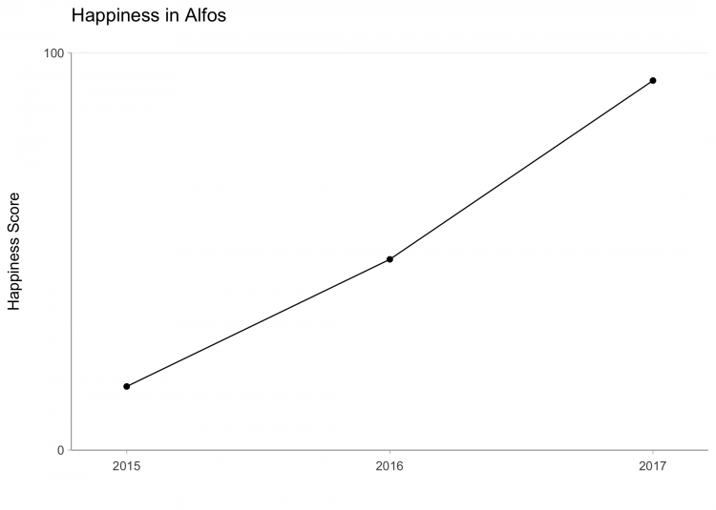

End of Block: 13 inc_hap_Alfos_nogrid

Start of Block: 16 inc_hap_Alfos_wgrid



Q47 Timing

First Click (1)

Last Click (2)

Page Submit (3)

Click Count (4)



inc_hap_Alfos_wgrid

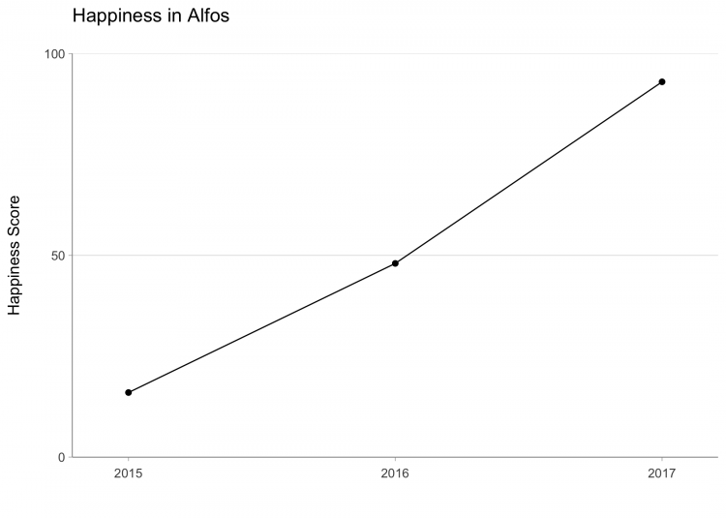

End of Block: 16 inc_hap_Alfos_wgrid

Start of Block: Sadness in Alfos



Q22   
Carefully read the following instructions.  
  
The next screen will display a graph of annual sadness scores for the city of Alfos over the last three years. The graph will be shown for 20 seconds. Study it carefully during this time. You will then be asked a question about this graph. Please answer the question as quickly but accurately as possible.  
  
  
When you are ready, proceed to view the graph.

End of Block: Sadness in Alfos

Start of Block: 19 inc_sad_Alfos_nogrid



Q53 Timing

First Click (1)

Last Click (2)

Page Submit (3)

Click Count (4)



inc_sad_Alfos_nogri



End of Block: 19 inc_sad_Alfos_nogrid

Start of Block: 22 inc_sad_Alfos_wgrid



Q55 Timing

First Click (1)

Last Click (2)

Page Submit (3)

Click Count (4)



inc_sad_Alfos_wgrid

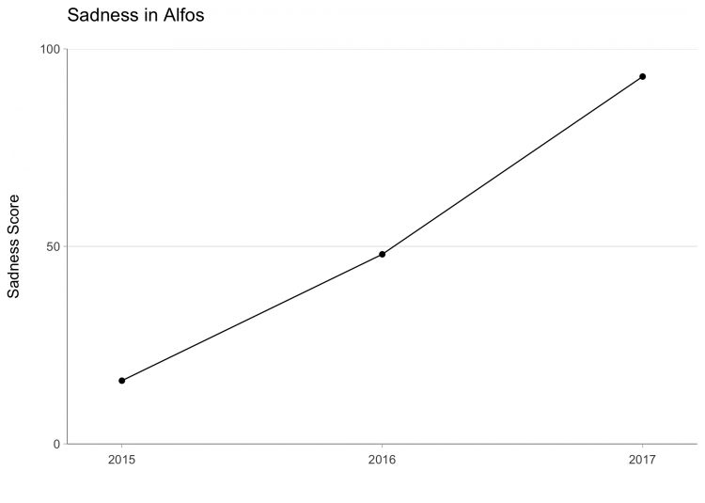

End of Block: 22 inc_sad_Alfos_wgrid

Start of Block: Qualification test (decreasing)



Q12 Use the graph below to answer the questions that follow.



Qualification test (

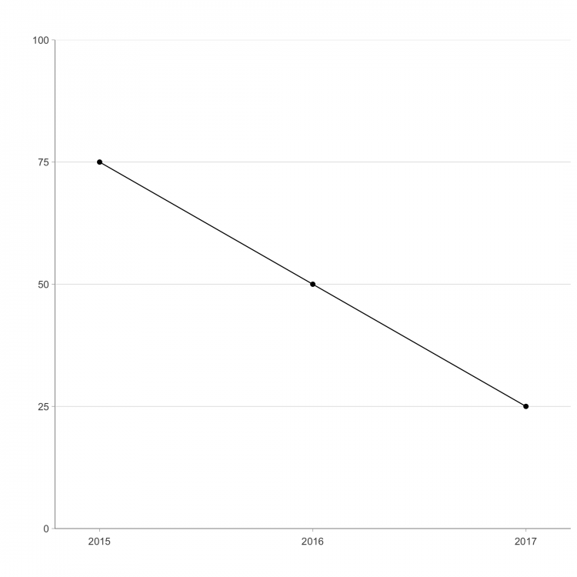



Q14 For the three years shown on the graph, which is the minimum value?

* 0 (1)
* 25 (2)
* 50 (3)
* 75 (4)
* 100 (5)



Q15 For the three years shown on the graph, which is the maximum value?

* 0 (1)
* 25 (2)
* 50 (3)
* 75 (4)
* 100 (5)



Q16 How much did the value change from 2015 to 2017?

* 0 (1)
* -25 (2)
* -50 (3)
* -75 (4)
* -100 (5)

End of Block: Qualification test (decreasing)

Start of Block: 3 dec_hap_Oswa_nogrid



Q23 Timing

First Click (1)

Last Click (2)

Page Submit (3)

Click Count (4)



dec_hap_Oswa_nogrid

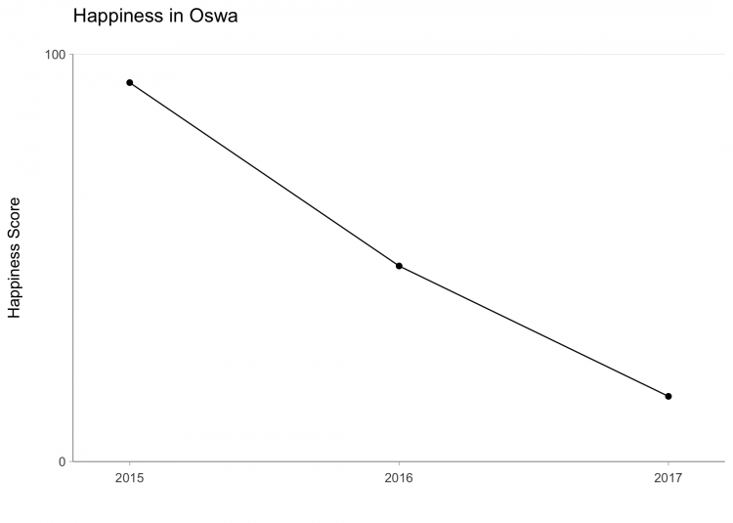

End of Block: 3 dec_hap_Oswa_nogrid

Start of Block: 6 dec_hap_Oswa_wgrid



Q25 Timing

First Click (1)

Last Click (2)

Page Submit (3)

Click Count (4)



dec_hap_Oswa_wgrid

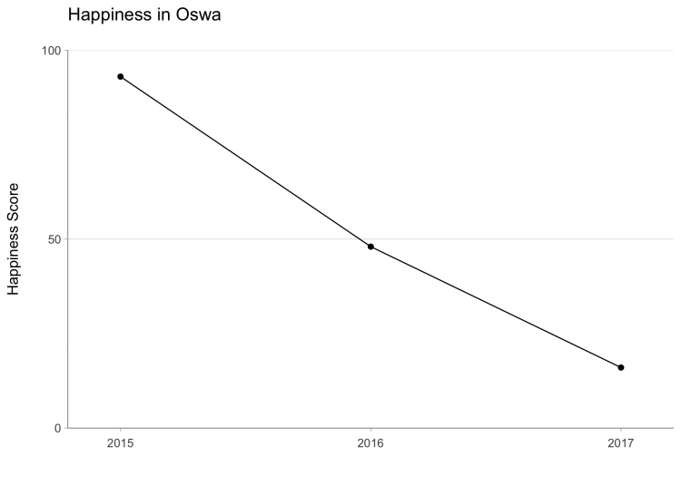

End of Block: 6 dec_hap_Oswa_wgrid

Start of Block: 9 dec_sad_Oswa_nogrid



Q33 Timing

First Click (1)

Last Click (2)

Page Submit (3)

Click Count (4)



dec_sad_Oswa_nogrid

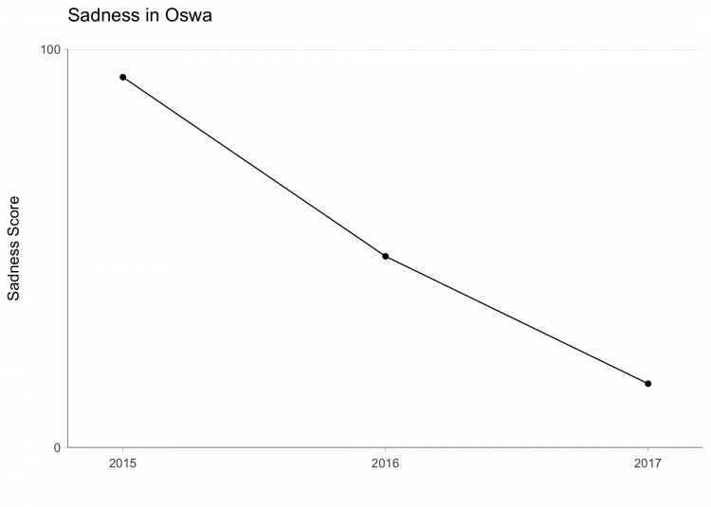

End of Block: 9 dec_sad_Oswa_nogrid

Start of Block: 12 dec_sad_Oswa_wgrid



Q35 Timing

First Click (1)

Last Click (2)

Page Submit (3)

Click Count (4)



dec_sad_Oswa_wgrid

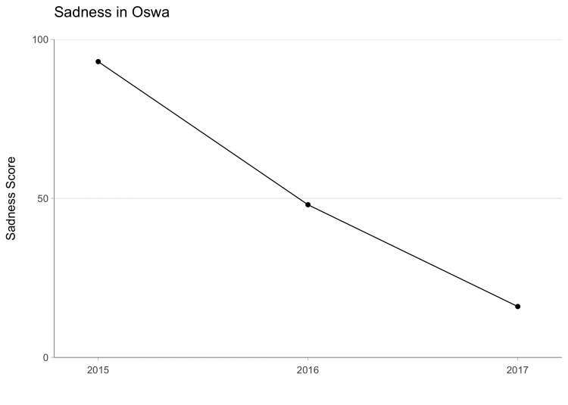

End of Block: 12 dec_sad_Oswa_wgrid

Start of Block: 2 dec_hap_Escor_nogrid



Q57 Timing

First Click (1)

Last Click (2)

Page Submit (3)

Click Count (4)



dec_hap_Escor_nogrid

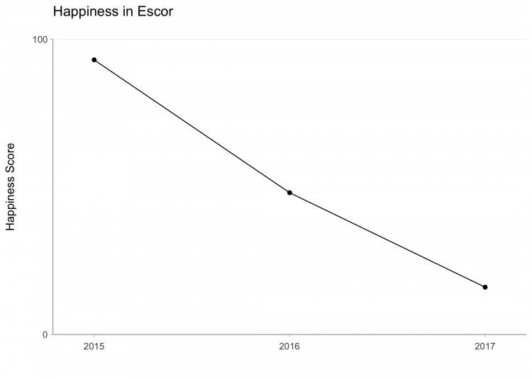

End of Block: 2 dec_hap_Escor_nogrid

Start of Block: 5 dec_hap_Escor_wgrid



Q59 Timing

First Click (1)

Last Click (2)

Page Submit (3)

Click Count (4)



dec_hap_Escor_wgrid

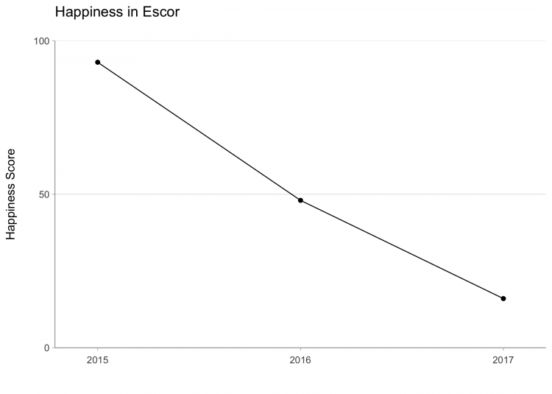

End of Block: 5 dec_hap_Escor_wgrid

Start of Block: 8 dec_sad_Escor_nogrid



Q65 Timing

First Click (1)

Last Click (2)

Page Submit (3)

Click Count (4)



dec_sad_Escor_nogrid

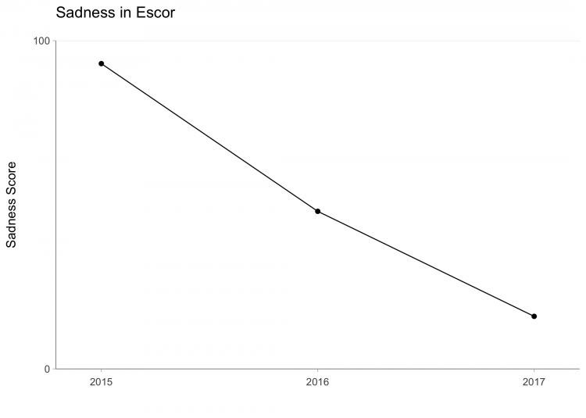

End of Block: 8 dec_sad_Escor_nogrid

Start of Block: 11 dec_sad_Escor_wgrid



Q67 Timing

First Click (1)

Last Click (2)

Page Submit (3)

Click Count (4)



dec_sad_Escor_wgrid

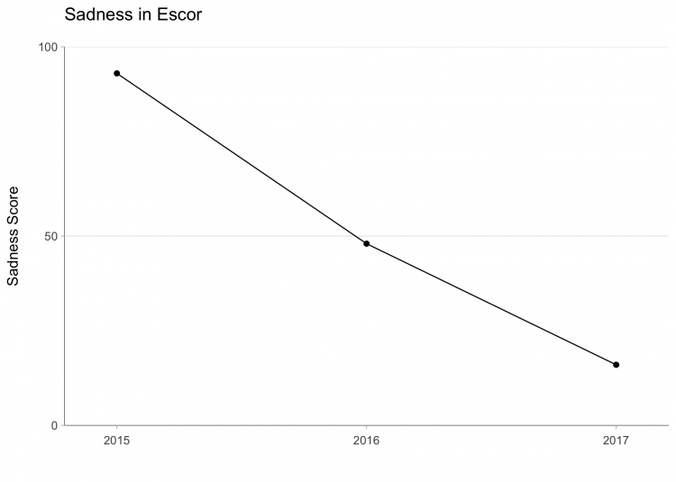

End of Block: 11 dec_sad_Escor_wgrid

Start of Block: 1 dec_hap_Alfos_nogrid



Q41 Timing

First Click (1)

Last Click (2)

Page Submit (3)

Click Count (4)



dec_hap_Alfos_nogrid

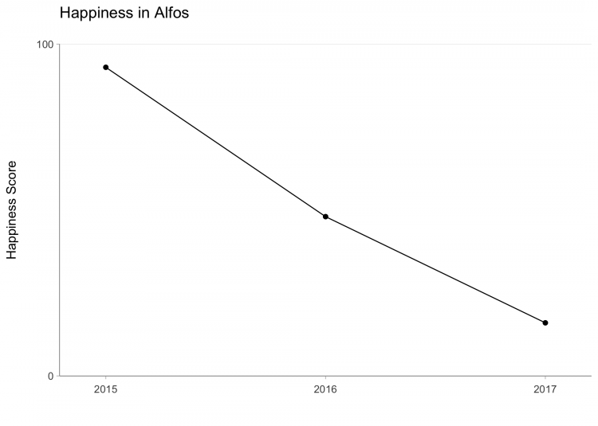

End of Block: 1 dec_hap_Alfos_nogrid

Start of Block: 4 dec_hap_Alfos_wgrid



Q43 Timing

First Click (1)

Last Click (2)

Page Submit (3)

Click Count (4)



dec_hap_Alfos_wgrid

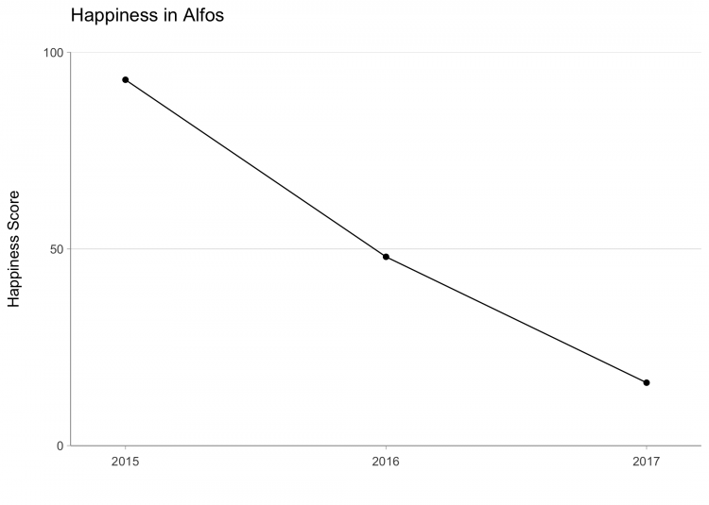

End of Block: 4 dec_hap_Alfos_wgrid

Start of Block: 7 dec_sad_Alfos_nogrid



Q49 Timing

First Click (1)

Last Click (2)

Page Submit (3)

Click Count (4)



dec_sad_Alfos_nogrid

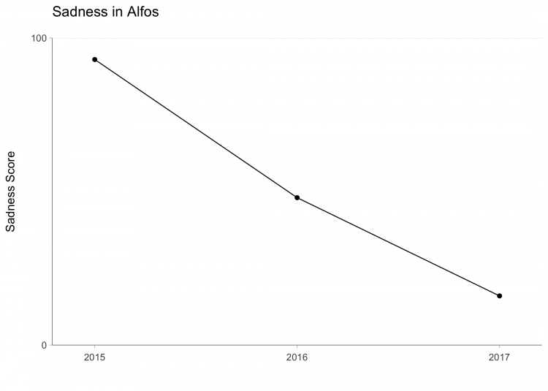

End of Block: 7 dec_sad_Alfos_nogrid

Start of Block: 10 dec_sad_Alfos_wgrid



Q51 Timing

First Click (1)

Last Click (2)

Page Submit (3)

Click Count (4)



dec_sad_Alfos_wgrid

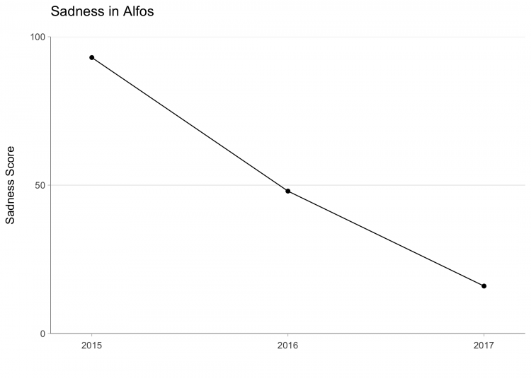

End of Block: 10 dec_sad_Alfos_wgrid